Лабораторная работа 3 ЗК ОДУ

Вариант 16

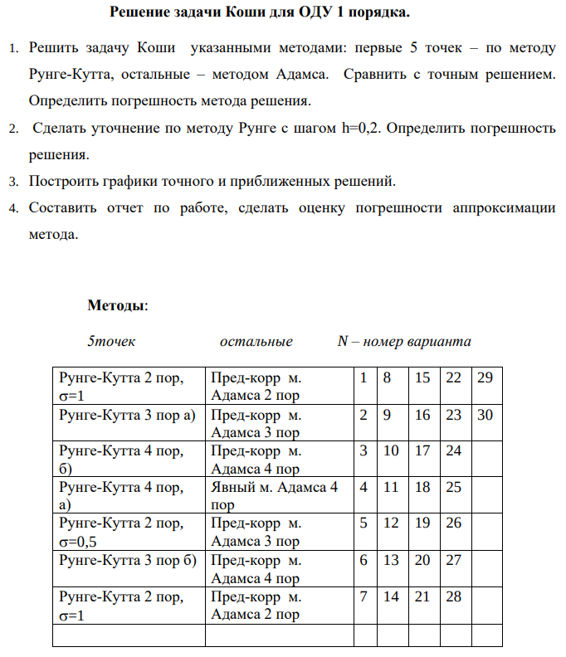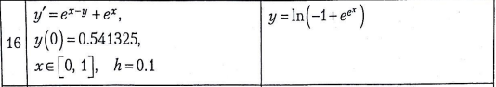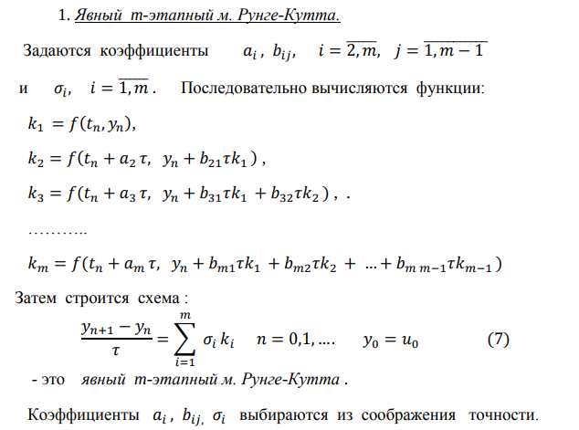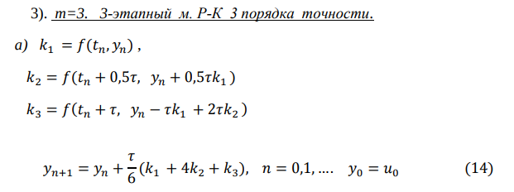

**Реализация метода Рунге Кутты 3 порядка а)**

def runge_kutta(h, xi, yi):

k1 = df(xi, yi)

k2 = df(xi + h/2, yi + k1*h/2)

k3 = df(xi + h, yi - h*k1 + k2*h*2)

y_next = yi + (k1 + 4*k2 + k3) * h / 6

return y_next

for i in range(0, 4):

y1[i+1] = runge_kutta(h1, x[i], y1[i])

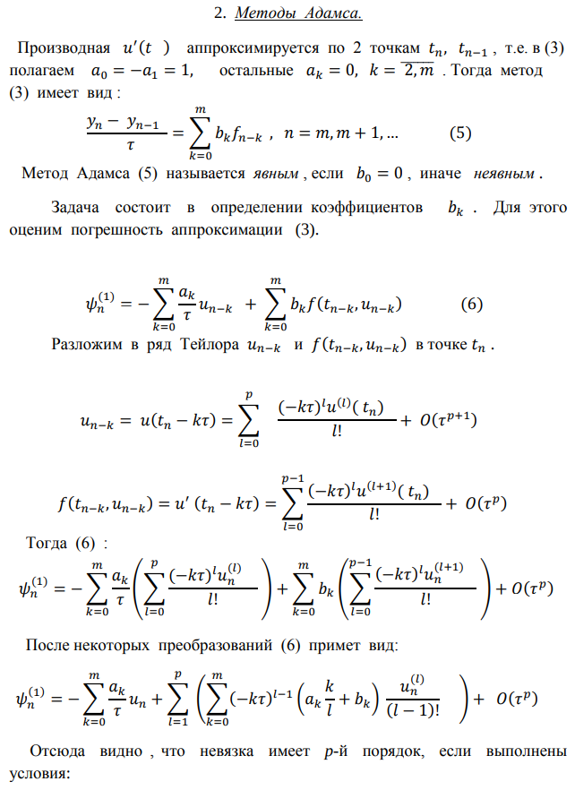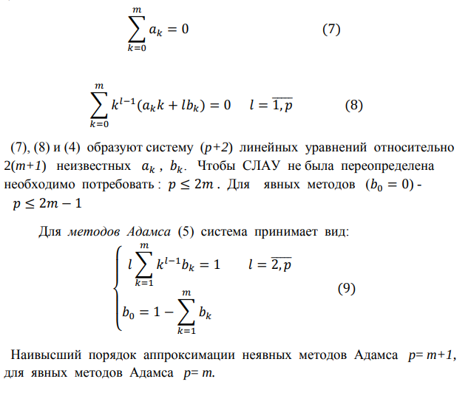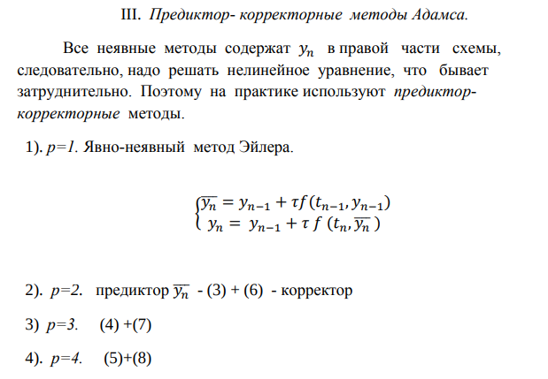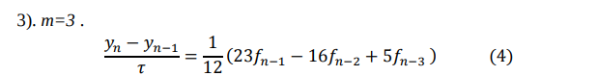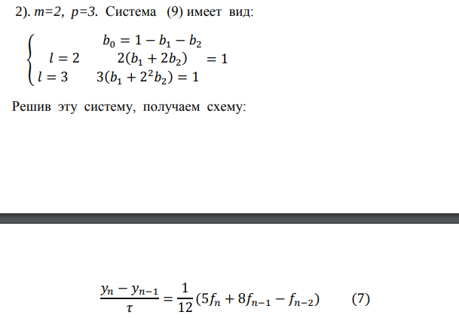

**Реализация метода предиктора-корректора Адамса**

for i in range(4, n-1):

# Предсказание (по Адамсу)

predictor = y1[i] + h1 * (23/12 * df(x[i], y1[i]) - 16/12 * df(x[i-1], y1[i-1]) + 5/12 * df(x[i-2], y1[i-2]))

# Коррекция (по Адамсу)

y1[i+1] = y1[i] + h1 * (5/12 * df(x[i+1], predictor) + 8/12 * df(x[i], y1[i]) - 1/12 * df(x[i-1], y1[i-1]))

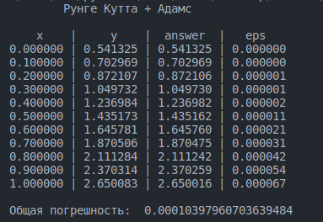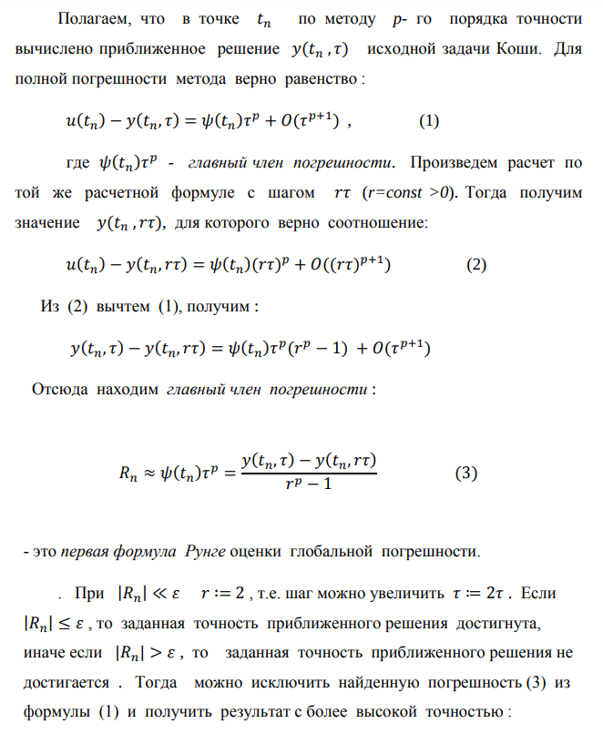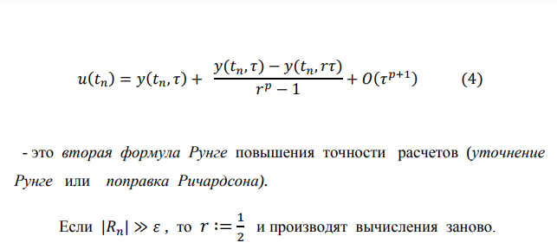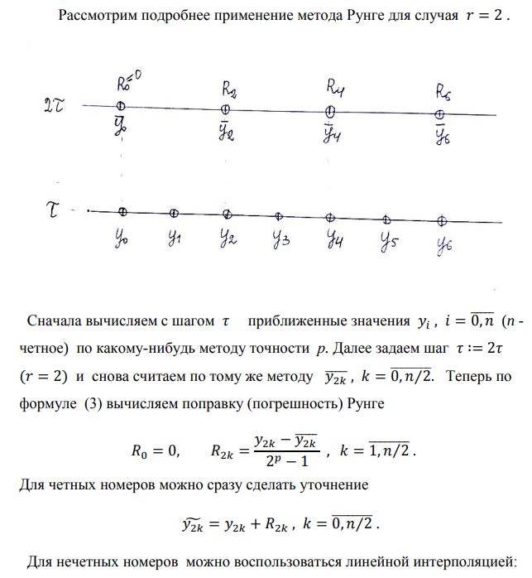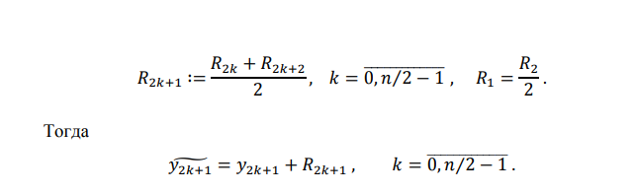

**Уточнение методом Рунге Ромберга**

h2 = 0.2

p = 3

r = 2

y2 = [0 for i in range(n)]

y2[0] = 0.541325

R = [0 for i in range(n)]

for i in range(0, 6, 2):

y2[i+2] = runge_kutta(h2, x[i], y2[i])

for i in range(6, n-2, 2):

predictor = y2[i] + h2 * (55/24 * df(x[i], y2[i]) - 59/24 * df(x[i-2], y2[i-2]) + 37/24 * df(x[i-4], y2[i-4]) - 3/8 * df(x[i-6], y2[i-6]))

y2[i+2] = y2[i] + h2 * (9/24 * df(x[i+2], predictor) + 19/24 * df(x[i], y2[i]) - 5/24 * df(x[i-2], y2[i-2]) + 1/24 * df(x[i-4], y2[i-4]))

for i in range(2, n, 2):

R[i] = (y1[i]-y2[i])/(math.pow(r, p) - 1)

y2[i] = y1[i] + R[i]

for i in range(1,n,2):

R[i] = (R[i+1] + R[i-1])/2

y2[i] = y1[i] + R[i]

